

**Canadian Federation of University Women - Saskatoon Inc.**



P.O. Box 7405, Saskatoon, SK S7K 4J3

www. sites.google.com/site/cfuwsaskatoon/home

***February-March 2016 Newsletter***

**Upcoming CFUW events**

**Monday, February 1, 2016**

W. A. Edwards Family Centre, 333-4th Ave. North

Time: 7:30 – 9:30 pm

Resolutions will be discussed.

**Monday, March 7th, 2016**

Frances Morrison Library

Time: 7:30 – 9:30 pm

International Women's Day - Film: To Be Determined

Contact Freda Toffolo for more information

**Monday, April 4th, 2016**

W. A. Edwards Family Centre, 333-4th Ave. North

Time: 7:30 – 9:30 pm

Speaker: Provincial Ombudsman, Mary McFayden. “A Foundation for Fairness”

**Monday, May 2nd, 2016**

Banquet and Annual General Meeting

Time: 5:00 - 9:00 pm

Speaker: Ernie Louttit, Author: *“Indian Ernie”* and *“More Indian Ernie – Insights from the Street”*

Tickets required

2 *Feb-Mar/16*

|  |  |  |  |
| --- | --- | --- | --- |
| **Board & Committee Chairs**  **President** Janie Charbonneau  **Past President** Gerlinde Sarkar  **Vice-President** Alix Tumback  **Treasurer** Michelle Rogers  **Secretary** Victoria Neufeldt  **(general meetings)**  **Secretary** Angela Schmidt  **(board meetings)**    **Membership** Marlene Chatterson  Dorma Guedo  Melinda Waltz  Rita Priestley  **Program** Freda Toffolo  Penny-Lynn Micklewright  Sherry Smith  Phyllis Austman  ***Convenors:***  **Book Sale** Alverta Polson  **Council of Women** Jean Thompson  Ruth Robinson  **Newsletter Editor** Tracy Muggli  Gerlinde Sarkar    **Scholarship** Mary McKay    **Publicity**  Malaika Charbonneau  Sherry Smith  **Archives** Margaret Hendry    **Social** Myrt Ryhorchuk  Cathy Fry  Donna Jean Gerrier  *A world of empowered women isn’t one where men are marginalized. It’s a world where everybody thrives.*  Purima Mane,  President and CEO of Pathfinders International |  | ***President’s Message***  **December 2015 Review**  On December 5th, we started the holiday season with our meeting and Christmas social. Everyone brought goodies and most of us sampled almost everything. Well done ladies.  Freda started us off with a “Card Match” game. The winners won prizes courtesy of Alix Tumback. Thank you Freda and Alix. The entertainment continued with Mary McKay's recitation of “King John's Christmas.” She even brought a red India rubber ball. Thank you Mary. Thank you as well, to Myrt Ryhorchuk for her organization to make the event successful.  On December 6th, Gerlinde Sarkar and I attended an event that CFUW co-hosted with GSA Saskatoon. It was a wonderful event that included dancers, singers and international foods. The event was held to commemorate the massacre at Montreal Polytechnic.  Also on December 6th, Eleanor Ritchie and I went to Brunskill School to present the school with a painting by Sharon Higham, titled “Aurora.” A special treat was that Eleanor was able to make the presentation to her granddaughter, a Brunskill student.  **January 2015**  Happy New Year!  Our first event of the year was a luncheon at the Park Town Hotel. Our speaker was Lori Blondeau.Lori is a performing artist in Saskatoon. She has shown her work worldwide. She spoke about how her art champions her culture and gender.  On February 1st, we will be discussing the resolutions put forth by CFUW. This year we have 5 resolutions. Please read them through. I sent them out on January 3, 2015.  **Membership Profiles**  Please send or email profiles that you have written about yourself. They are not CV's, simply a sketch about where you've lived, studied and worked. Why did you join CFUW? What were/are the highlights of your career? Include anecdotes that show how women's lives and careers have changed.  The profiles should be 100 to 250 words long. They will be put in the newsletter, collected into a book, and be archived for our centennial. This collection will be an initiative to take to the CFUW AGM in St Catherine’s.  Stay warm, and enjoy the pristine beauty of a fresh snowfall.    *Janie Charbonneau, President* |  |

3 *Feb-Mar/16*

|  |  |
| --- | --- |
| Report for CFUW Saskatoon Inc. fall ne At the **World Economic Forum**, the Secretary-General of the United Nations announced the first ever High-Level Panel on Women's Economic Empowerment. The panel is a group of influential leaders from government, the UN, business and civil society, appointed by the Secretary-General. They will make recommendations for key actions to achieve the Global Goals, as they relate to the economic empowerment of women and girls. To learn more about this High-Level Panel, [click here.](http://cfuw.us12.list-manage.com/track/click?u=8efb82640cb8bc1fd889b4668&id=133647f0d9&e=9ffd4f548e)  **Interest Groups**  The Interest Groups have been running smoothly this year. We've been reading excellent books, eating delicious meals, visiting art galleries and enjoying discussions on a wide variety of topics.  **Website**  Our website is up and running. It's looking good.  If anyone has input for the site, contact Malaika Charbonneau (contact info in club address book).  **Scarves**  We are planning to select a charity (I was thinking Lighthouse) and knitting scarves. We will source the yarn through donations, thrift shops etc. Then, being just slightly less than charitable, we can arrange for media coverage for the donation.  It would be a good way to raise our profile in the community.  Don't forget to visit our **Facebook page** and send Malaika photographs and blurbs that may be included. | ***Membership Committee Report***  Our membership stands at 78 and we are very fortunate to have new members who are becoming very active in the Club.  Dorma Guedo is reviewing old membership cards and preparing a list of members to invite to our 100th Anniversary which we will be celebrating in 2018. A gracious thank you to Dorma for doing this.  It is interesting that some of our old University of Saskatchewan professors were members; e.g. Hilda Neatby, Madame Cameron to name two.  We welcome new member Jebunnesah Chapola who can be reached at [jebunnesah@gmail.com](mailto:jebunnesah@gmail.com) or [Jebunnesah.chapola@usask.ca](mailto:Jebunnesah.chapola@usask.ca)  If you have friends who would be interested in joining, please bring them to the Resolutions Meeting on February 1st.  This will demonstrate to prospective members the Advocacy actions that CFUW is promoting.  *Marlene Chatterson, Membership Committee Chair*    ***Scholarship Committee Report***  The website, concerning our scholarships, is up to date as to the current amount of the awards.  The links to the U of S for the Graduate and Undergraduate Scholarship application forms are correct and the applications for the Graduate Scholarships are due February 1st.    *Respectfully submitted, Mary McKay - Chair* |

*4 Feb-Mar/16*

***Additional Interest Items***

Saskatoon Council of Women will have a display at the Heritage Fair on Sunday, February 7, noon until 5:00 pm at the Western Development Museum.  The display will feature the Saskatoon Women’s Hall of Fame.

The Saskatoon Council of Women is excited to be hosting the National Council of Women for its AGM, June 9 – 12, 2016.  There will be a request for help from the federates closer to the date.

Young BPW is very proud to present their first-ever Movie Night which will be held on:

Thursday, January 28th, 2016  
5:30 - 8:30pm  
Western Development Museum

This event will feature an airing of the inspiring documentary, Girl Rising, which journeys around the globe to witness the strength of the human spirit and the power of education to change the world!

Everyone is encouraged to attend. Proceeds raised will be donated to the BPW Saskatoon Educational Bursaries.

Last chance to get your tickets:  <http://buff.ly/1JL3UGS>

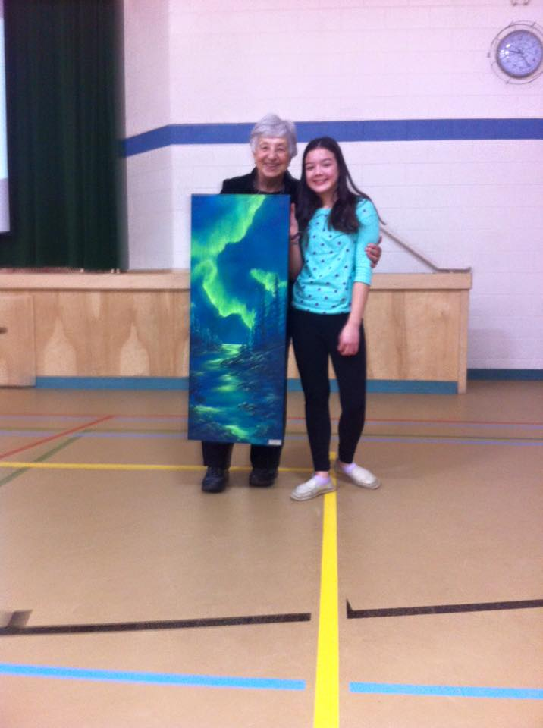 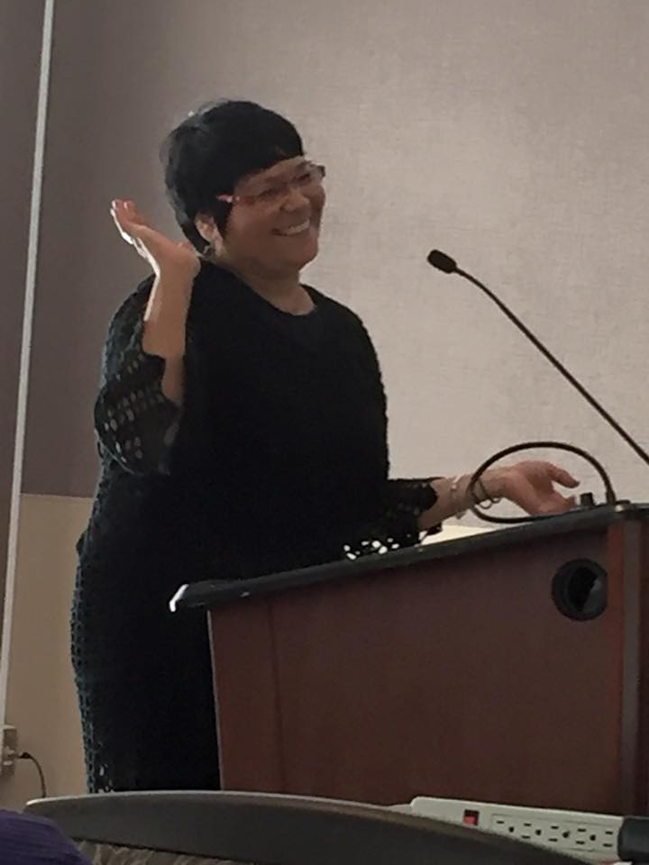

***Eleanor Ritchie with her granddaughter at Brunskill School. Presentation of Sharon Higham’s piece, “Aurora.”***

***Lori Blondeau, Performance Artist***

***Speaking at CFUW-Saskatoon January Luncheon***